Name:_________________________

**Playing a Sound - MakeCode**

**What you need:**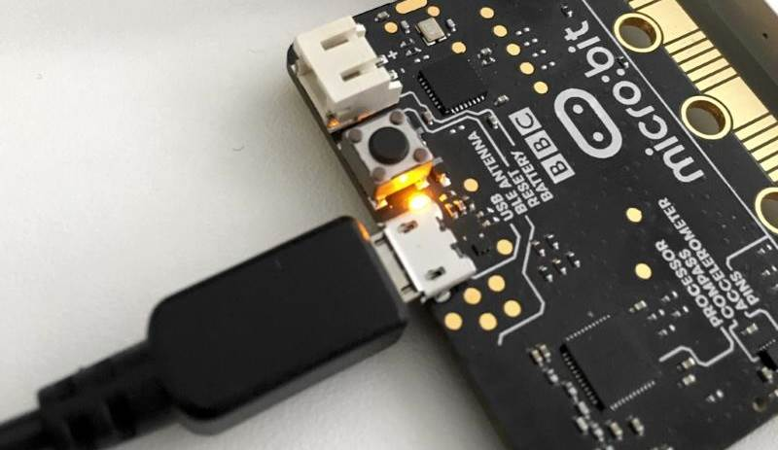

1. A computer with a USB port
2. V2.0 micro:bit
3. USB cable

**Setup:**

1. Plug in your micro:bit with the USB cable. The small USB mircoB end goes to the micro:bit and the regular USB end goes to the computer.
2. In a browser, go to <https://makecode.microbit.org/>. This is where you will program your micro:bit.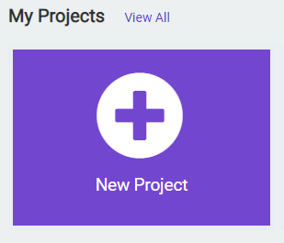
3. Click on ‘New Project’
4. You can name your project whatever you want, but you should name it based on the title of the lab. In this case, ‘Playing a Sound’

**Instructions:**

1. To start, we will work in the **forever** code block. This block will continuously execute the code that we put inside this block. To play a sound, click on **Music** tab on the left hand side of the screen: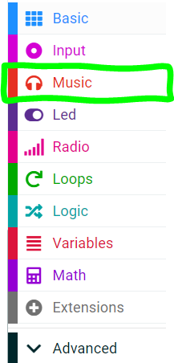
2. We want to use the **play sound** code block from the menu. Click and drag it to the **forever** code block: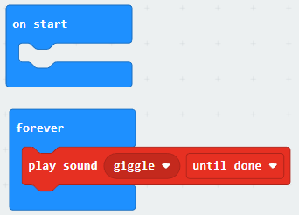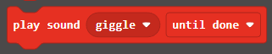
3. The spot where it says **giggle** with the dropdown arrow is where you can select what sound you want to play.
4. Click the **Download** button on the bottom on the bottom left hand side of the screen. This will upload your program to the micro:bit. You should be able hear the sound you chose playing on the micro:bit!

**You Try It!**

What other sounds can you play?